CLIN1-Application Creation

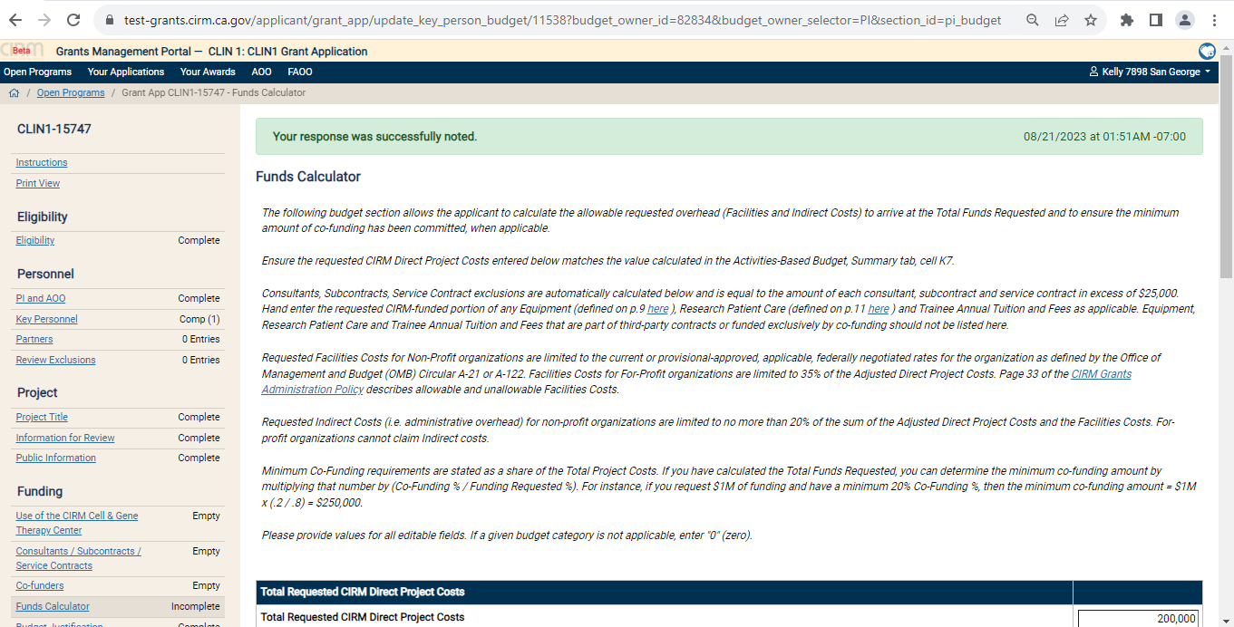

If we give Total requested Project cost alone and click save.

It shows “Your response was successfully noted”.

But in Fund Calculator it shows “Incomplete”.

It will show the error that we need to fill all the fields.

Review Meeting:

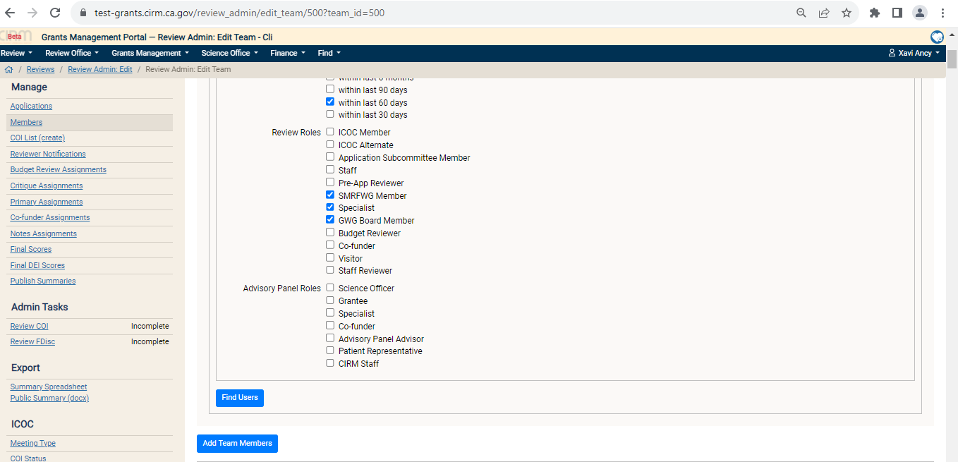

We are selecting 3 review roles.

For the 3 review roles, we are selecting 1 person.

And select one more person for unselected review roles also.

It didn’t show any message.

